**Supplementary file 3: Reflective marker placement**

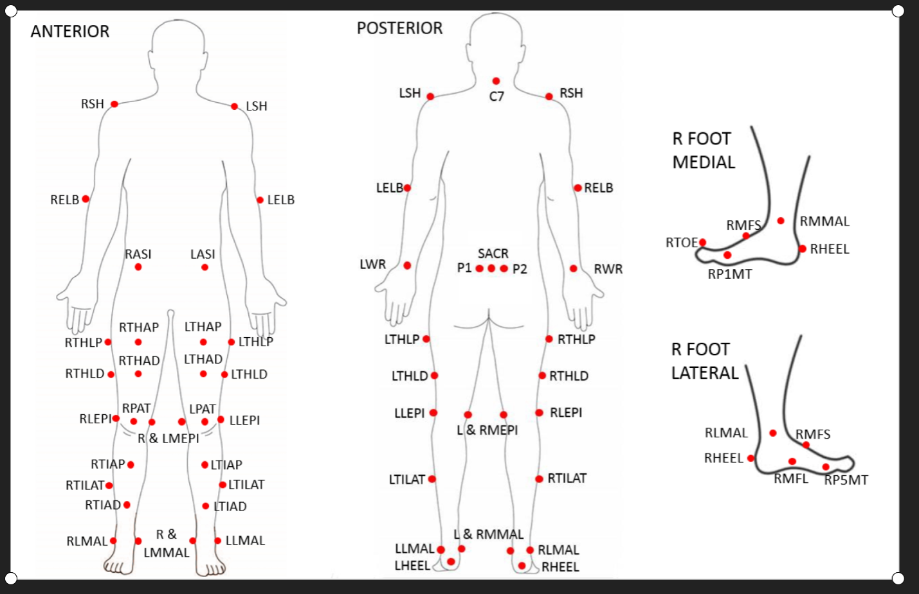

For the upper limbs, markers will be placed over the lateral epicondyle on the humerus and the dorsal aspect of the wrist. For the trunk, markers will be placed on the acromio-clavicular joints and over the spinous process of the 7th cervical vertebra. For the pelvis, markers will be placed over the left and right anterior superior iliac spines and posterior superior iliac spines, and one marker will be placed on the sacrum (mid distance between the posterior superior iliac spine markers). For the lower-limbs, markers will be placed over the medial and lateral femoral epicondyles (and the patella) and the medial and lateral malleoli. Foot markers will be placed over participant’s shoes at the heel, the medial and lateral midfoot, the medial aspect of the 1st metatarso-phalangeal joint, the lateral aspect of the 5th metatarso-phalangeal joint, and on the dorsal surface of the 1st toe. Four tracking markers will be placed over the anterolateral aspect of the thigh and three tracking markers over the middle third of the shank.